Cairo University Faculty of Computers and Information



**Software Engineering II**

**Software design specification document**

**2020**

**Project Team**

|  |  |  |  |
| --- | --- | --- | --- |
| **ID** | **Name** | **Email** | **Mobile** |
| 20170335 | Yousef ahmed | Yousefa.mohamed12gmail.com | 01100515599 |
| 20170339 | Yousef ehab |  |  |
| 20170340 | Yousef hassan |  |  |
| 20170178 | Omar tarek |  |  |
|  |  |  |  |
|  |  |  |  |

**TA:EsraaSalem**

Contents

Class diagram design 2

Sequence diagram design 3

Github repository link 4

# Class diagram design

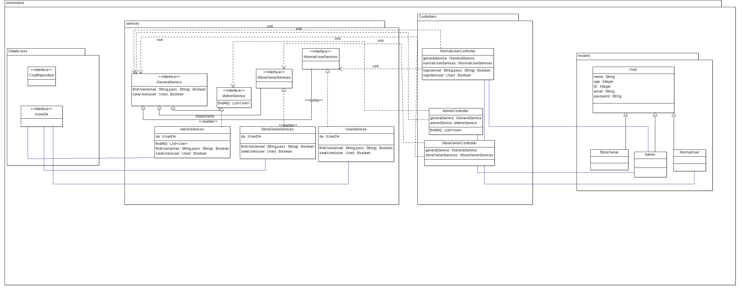

# 

# Sequence diagram design

**Register sequence diagram**

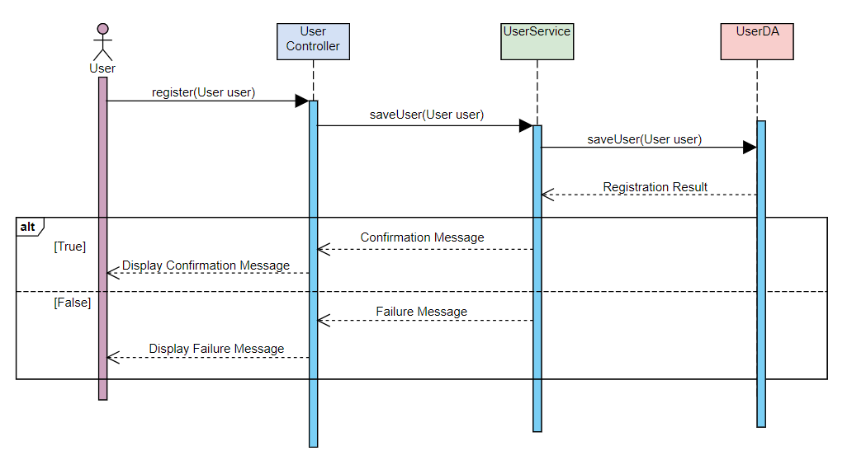

**Login sequence diagram**

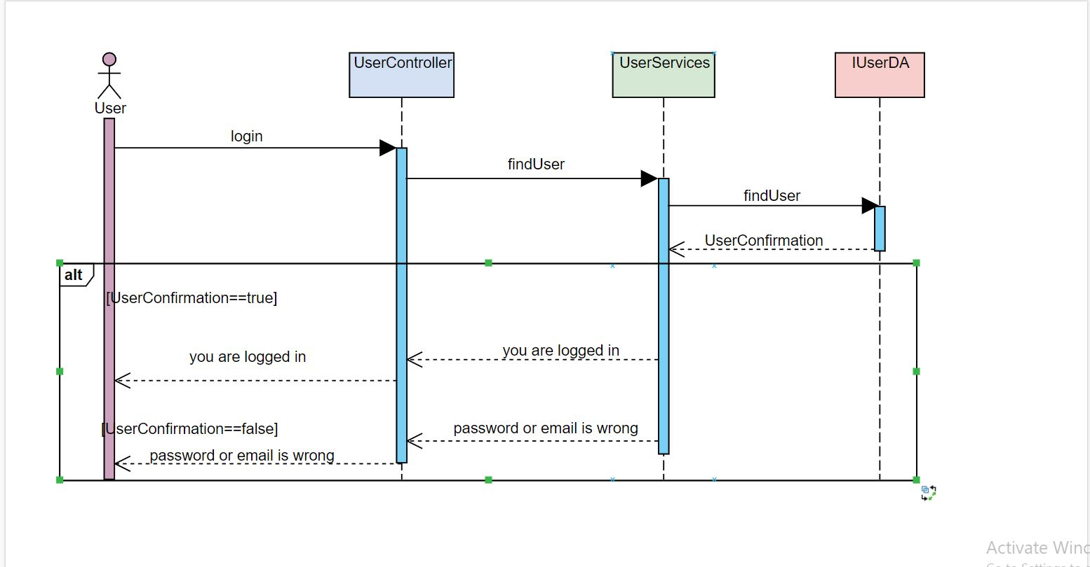

**Login sequence diagram**

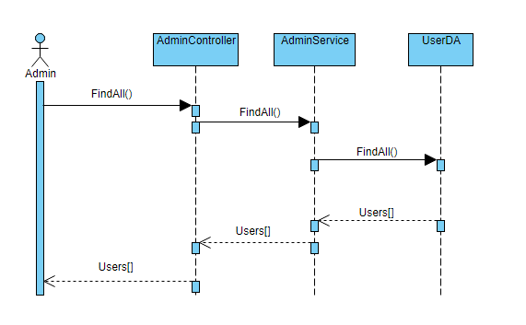

# Github repository link

* <https://github.com/yousefahmed98/onlineStorePlatform>